Payroll Management System for Information Technology Company

Version 1.0

Revision History

|  |  |  |  |
| --- | --- | --- | --- |
| **Date** | **Version** | **Description** | **Author** |
| 31/10/2019 | 1.0 | Final | Tạ Văn Hiệp |
|  |  |  |  |
|  |  |  |  |
|  |  |  |  |

Table of Contents

1. Deleting feedback 4

1.1 Brief Description 4

1.2 Actor Administrator. 4

2. Flow of Events 4

2.1 Basic Flow 4

3. Special Requirements 5

4. Preconditions 5

5. Postconditions 5

6. Extension Points 5

Use-Case Specification: Delete FeedBack

# Deleting feedback

## Brief Description

This use case defines steps of deleting an existing feedback from the system.

Accountant or employee can easily delete a feedback from the system.

## Actor Accountant, employee.

# Flow of Events

## Basic Flow

The system accountant or employee selects the feedback to delete. The accountant or employee deletes the database management parameter that holds feedback information.

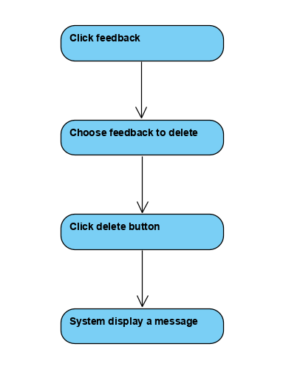



Basic flow of Removing Department

# Special Requirements

No special requirements.

# Preconditions

Login.

# Postconditions

No postconditions.

# Extension Points

No extension points.